Tire Design

Bulldogs Racing
BR2016

1. Overview

The tires are the only interface between the vehicle and the road (hopefully). Every non-aerodynamic force passes through one of the four tire contact patches. Therefore it is of the utmost importance to choose tires that fit the vehicle design characteristics.

2. Design Criteria

A vehicle should respond to left and right turns in a similar and predictable manner. Assuming that the vehicle center of gravity lies along the xz plane (as is typically the case), tires should be symmetric across this xz plane (see SAE axis convention). However vehicles do not typically have an even front to rear weight bias. Therefore front and rear tires may be different to account for this asymmetry.

Tire load sensitivity is the most important criteria used for addressing this design problem. As a tire's vertical load increases its coefficient of friction decreases as shown in Figure 1. Therefore in the case of a static vehicle, the front to rear tire coefficients of friction at static load should match the front to rear weight bias in order for all four tires to produce maximum force before slipping. This model is complicated by considering longitudinal, lateral, and diagonal load transfer.

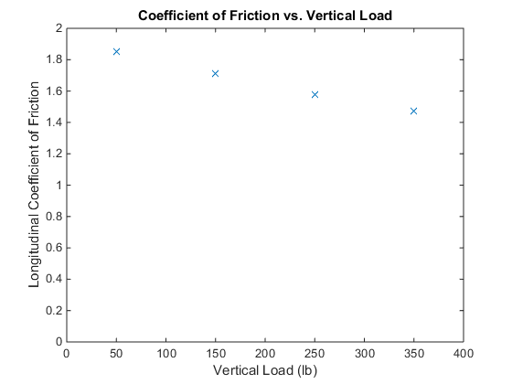Figure 1: Tire load sensitivity of a Hoosier bias-ply slick tire.

BR2016 will have a front to rear weight bias of 55-60%, therefore the rear tires should be able to handle more load while maintaining a 55-60% coefficient of friction ratio between front and rear tires. This can only be achieved with larger diameter or larger tread width tires.

3. Wheel Diameter

Two wheel diameters pervade FSAE vehicles: 10” and 13”. 10” rims are usually reserved for lightweight vehicles that are nimble and quick. BR2016 will not be one of these cars due to the nature of batteries, as described in “Mechanical Design Overview.doc”. Additionally Bulldogs Racing has experience with 13” rims with its championship 2014 car. Therefore 13” rims were chosen for BR2016.

4. Tire Selection

Formula SAE 13” tires were compiled into a spreadsheet that listed geometric parameters, price, and whether or not data exists on performance characteristics. Three manufacturers stood out as having the largest selection of tires that are most readily available: Hoosier, Avon, and Goodyear. Each manufacturer offered various tire tread widths for both slicks and wets, meeting the requirement of section 2.

Tire data was then used to determine which tires performed best in lateral and longitudinal acceleration. All of the Hoosier tires, and one of the Goodyear tires were tested by the Tire Test Consortium. Unfortunately Avon tire data was provided by Avon in a separate format, meaning that relative comparisons could not be made from Avon to neither Hoosier nor Goodyear. Analysis of the Hoosier 7” tire and the Goodyear 7” tire showed that the Hoosier tire has a higher coefficient of friction across all four tire loads for both lateral and longitudinal acceleration (see Figure 2).

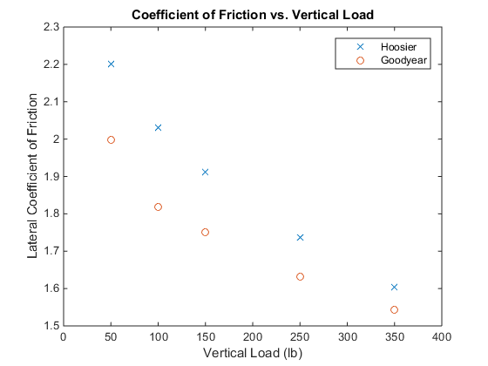Figure 2: Hoosier 7" vs. Goodyear 7" in lateral coefficient of friction.

Other factors that influenced tire decisions were price, weight, availability, public opinion (on the FSAE forum), and familiarity. Not only did Hoosier tires perform better, but they also cost less, are more available, and are more familiar than Goodyears. A conglomeration of these factors resulted in the decision to use the 6” and 8” tread width Hoosier tires, resulting in a tire tread width ratio of 57%, which closely matches the expected rear weight bias.

